|  |  |
| --- | --- |
| Ex:No:2 | Styling ebook library website using CSS |
| Date:  06/08/2021 |

**Aim :**

To create the ebook library website using html.

**Procedure:**

1)image map-used to redirect to book sections page

2)Table-to show the book details

3)Form-To create the login/signup form

4)Fieldset,legend-To place input element in the form

5)input

Date-To get the date as the input

Radio-To get the gender input

check-To accept the terms and condition

tel-for phone number

6)video-To insert the ebook explanation video in the home page.

7)header and footer-To create the header and footer for this website

**Program:**

**1.index.html:**

<!DOCTYPE html>

<html>

<head>

    <title>ebook library</title>

    <link rel="stylesheet" href="./index.css">

    <!--adding fonts-->

   <link href="https://fonts.googleapis.com/css2?family=Courgette&family=Style+Script&display=swap" rel="stylesheet">

    <link href="https://fonts.googleapis.com/css2?family=DM+Serif+Display:ital@1&display=swap" rel="stylesheet">

</head>

<body>

    <header>

        <h1 class="header_title">EBook Library</h1>

    </header>

    <ul class="nav-bar">

       <li class="nav-menu"><a class="nav-link" href="./index.html">home</a></li>

       <li class="nav-menu"><a class="nav-link" href="./sections/contact.html">contact</a></li>

       <li class="nav-menu"><a class="nav-link" href="./sections/gallery.html">gallery</a></li>

       <li class="nav-menu"><a class="nav-link" href="./sections/aboutus.html">about us</a></li>

       <li class="reg_btn"><a href="./login.html" class="nav-link">register</a></li>

       <li class="dropdown">

            <button class="dropbtn">categories</button>

            <div class="dropdown-content">

                <a href="./sections/art.html" class="section_link">art</a>

                <a href="./sections/business.html" class="section_link">business</a>

                <a href="./sections/technology.html" class="section_link">technology</a>

            </div>

        </li>

    </ul>

    <!--<ul class="sections_container">

      <li class="section"><a class="section_link"></a>art</li>

      <li class="section"><a class="section_link"></a>science</li>

      <li class="section"><a class="section_link"></a>technology</li>

    </ul>-->

    <!--<a href="./login.html"><button class="login_btn">login</button></a>-->

    <div class="book_shelf" usemap="#books">

        <h2 class="book_shelf_quotes">"The book collections"</h2>

    </div>

    <div class="cover_image_container">

        <img class="cover_image" usemap="#books"

            src="https://images.pexels.com/photos/207662/pexels-photo-207662.jpeg?auto=compress&cs=tinysrgb&dpr=2&w=500">

        <h3 class="cover_image_desc">please select book from the above books shelf picture</h3>

        <map name="books">

            <area shape="rect" coords="84,84,84,84" href="./sections/art.html">

            <area shape="rect" coords="114,294,370,450" href="./sections/business.html">

        </map>

    </div>

    <div class="book_details">

    <h3 class="book_details_title">available book sections</h3>

    <table>

        <tr>

            <td colspan="2">section name</td>

            <td colspan="2">No of books</td>

            <td>section no</td>

        </tr>

        <tr>

            <td colspan="2">art</td>

            <td colspan="2">500</td>

            <td>1</td>

        </tr>

        <tr>

            <td colspan="2">business</td>

            <td colspan="2">267</td>

            <td>2</td>

        </tr>

        <tr>

            <td colspan="2">mystery</td>

            <td colspan="2">503</td>

            <td>3</td>

        </tr>

        <tr>

            <td colspan="2">science</td>

            <td colspan="2">768</td>

            <td>4</td>

        </tr>

        <tr>

            <td colspan="2">computer</td>

            <td colspan="2">500</td>

            <td>5</td>

        </tr>

    </table>

    </div>

    <iframe style="width: 100%;height: 75vh;" src="https://www.youtube.com/embed/GZosR1twLJs" title="YouTube video player"

        frameborder="0" allow="accelerometer; autoplay; clipboard-write; encrypted-media; gyroscope; picture-in-picture"

        allowfullscreen></iframe>

    <footer class="footer">

        <h2>Thank you</h2>

    </footer>

</body>

<!--

<frameset cols="25%,75%">

    <frame src="frame1.html">

        <frame src="frame2.html">

</frameset>-->

</html>

**1.index.css**

    table,

    td,

    tr {

    border: 3px solid #C5CFD5;

    border-collapse: collapse;

    color: rgb(255, 255, 255);

    text-align: center;

    font-weight: bold;

    }

    table{

        width: 60%;

        height: 75vh;

        font-size: 4vh;

        margin: 0 auto;

        background: #348F50;  */* fallback for old browsers */*

background: -webkit-linear-gradient(to left, #56B4D3, #348F50);  */* Chrome 10-25, Safari 5.1-6 */*

background: linear-gradient(to left, #56B4D3, #348F50); */* W3C, IE 10+/ Edge, Firefox 16+, Chrome 26+, Opera 12+, Safari 7+ */*

 }

body{

*/*background: url('https://images.pexels.com/photos/7171398/pexels-photo-7171398.jpeg?auto=compress&cs=tinysrgb&dpr=2&w=500');*/*

    font-size: 3vh;

    margin: 0;

    font-family: 'DM Serif Display', serif;

}

header,footer{

    padding: 2vw 3vh;

    height: 20%;

    text-align: center;

    color: white;

    background: #12c2e9;  */* fallback for old browsers */*

    background: -webkit-linear-gradient(to right, #f64f59, #c471ed, #12c2e9);  */* Chrome 10-25, Safari 5.1-6 */*

    background: linear-gradient(to right, #f64f59, #c471ed, #12c2e9); */* W3C, IE 10+/ Edge, Firefox 16+, Chrome 26+, Opera 12+, Safari 7+ */*

    margin-top: -1vh;

}

*.nav-bar*{

    margin:0 auto;

    background-color:#333333;

    padding: 15px 0px;

    position: sticky;

    top:0%;

}

*.nav-menu*{

    display: inline;

    background-color:#333333;

    margin: 0;

    padding:15px 15px;

}

*.nav-menu:hover*{

    padding: 15.5px 15px;

    background-image: linear-gradient(to right, #f64f59, #c471ed, #12c2e9);

}

*.nav-link*{

    text-decoration: none;

    color: white;

    font-size: 3vh;

}

*.reg_btn*{

   text-decoration: none;

   display: inline;

   float: right;

   color: white;

   margin-right: 1%;

   background-color:rgb(4,170,109);

   padding: 7px 15px;

   margin-top: -7px;

   border-radius: 20px;

}

*.reg_btn:hover*{

 background: #12c2e9;  */* fallback for old browsers */*

    background: -webkit-linear-gradient(to right, #f64f59, #c471ed, #12c2e9);  */* Chrome 10-25, Safari 5.1-6 */*

    background: linear-gradient(to right, #f64f59, #c471ed, #12c2e9); */* W3C, IE 10+/ Edge, Firefox 16+, Chrome 26+, Opera 12+, Safari 7+ */*

}

*.header_title*{

    text-align: center;

}

*@keyframes* anim2{

            0% {background:linear-gradient(to right, #f12711, #f5af19);}

            20% {background:linear-gradient(to right, #8360c3, #2ebf91)}

            40% {background:linear-gradient(to right, #ff416c, #ff4b2b);}

            60% {background:linear-gradient(to right, #11998e, #38ef7d); }

            80% {background: linear-gradient(to right, #fc466b, #3f5efb);}

            100% {background: linear-gradient(to right, #22c1c3, #fdbb2d)}

        }

*.book_shelf*{

            width: 100%;

            height: 70vh;

            margin-bottom: 4vh;

            text-align: center;

            margin-top: 0;

            background: linear-gradient(to left, #556270, #4ECDC4);

            animation-name:anim2 ;

            animation-duration: 4s;

            animation-iteration-count: infinite;   */*to specify number of repeatation of animation*/*

            animation-delay: 1s;

            animation-timing-function: linear;

            box-sizing: border-box;

        }

*.book_shelf_quotes*{

    margin: 0;

    color:rgb(255, 255, 255);

    font-family: 'Style Script', cursive;

    font-family: 'Courgette', cursive;

    padding-top: 15%;

    font-size: 7vh;

}

*.cover_image*{

    width: 100%;

    height: 85vh;

}

*.cover_image_container*{

    margin-top: -4vh;

}

*.cover_image_desc*{

    padding: 6vh 2vw;

    background: #e65c00;  */* fallback for old browsers */*

background: -webkit-linear-gradient(to left, #F9D423, #e65c00);  */* Chrome 10-25, Safari 5.1-6 */*

background: linear-gradient(to left, #F9D423, #e65c00); */* W3C, IE 10+/ Edge, Firefox 16+, Chrome 26+, Opera 12+, Safari 7+ */*

  text-align: center;

    margin-top: -1vh;

}

*.book_details*{

margin-top: -3.5vh;

text-align: center;

background: #00416A;  */* fallback for old browsers */*

background: -webkit-linear-gradient(to left, #E4E5E6, #00416A);  */* Chrome 10-25, Safari 5.1-6 */*

background: linear-gradient(to left, #E4E5E6, #00416A); */* W3C, IE 10+/ Edge, Firefox 16+, Chrome 26+, Opera 12+, Safari 7+ */*

padding: 3vh 2vw;

}

*.book_details_title*{

   background: #ee0979;  */* fallback for old browsers */*

background: -webkit-linear-gradient(to left, #ff6a00, #ee0979);  */* Chrome 10-25, Safari 5.1-6 */*

background: linear-gradient(to left, #ff6a00, #ee0979); */* W3C, IE 10+/ Edge, Firefox 16+, Chrome 26+, Opera 12+, Safari 7+ */*

    color: white;

    padding: 5vh 2vw;

    width: 56%;

    margin: 3vh auto;

    border-radius: 50px;

}

*.dropbtn* {

  background-color: #333333;

  color: white;

  font-size: 16px;

  border: none;

  cursor: pointer;

}

*.dropdown* {

  position: relative;

  display: inline-block;

}

*.dropdown-content* {

  display: none;

  position: absolute;

  background-color: #f9f9f9;

  min-width: 160px;

  box-shadow: 0px 8px 16px 0px rgba(0,0,0,0.2);

  z-index: 1;

  margin-top: 2vh;

}

*.dropdown-content* a {

  color: black;

  padding: 12px 16px;

  text-decoration: none;

  display: block;

}

*.dropdown-content* a*:hover* {    background-image: linear-gradient(to right, #f64f59, #c471ed, #12c2e9);

}

*.dropdown:hover* *.dropdown-content* {

  display: block;

}

**2.login.html**

<!DOCTYPE *html*>

<html>

<head>

    <title>login</title>

    <link *rel*="stylesheet" *href*="./register.css">

</head>

<body>

    <div  *class*="form-container" *style*="margin-top: 15vh;">

        <form>

            <h2 *style*="text-align: center;font-size: 6vh;padding: 2vw 2 vh;">Login</h2>

            <fieldset *style*="width: 50%;margin: 0 auto;">

                <legend *for*="email">email :</legend>

                <input *style*="width: 89%;padding: 1.5vh 1.5vw;" *type*="text" *name*="email">

            </fieldset>

            <fieldset *style*="width: 50%;margin: 0 auto;">

                <legend *for*="password">password :</legend>

                <input *style*="width: 89%;padding: 1.5vh 1.5vw;" *type*="text" *name*="password">

            </fieldset>

            <fieldset *style*="width: 50%;margin: 0 auto;">

                <legend *for*="confirm_password">confirm password :</legend>

                <input *style*="width: 89%;padding: 1.5vh 1.5vw;" *type*="text" *name*="confirm_password">

            </fieldset>

            <div *style*="width: 50%;margin: 0 auto;margin-top:1vw">

                <input *type*="checkbox" *value*="agree">

                <label>I agree</label><br /><br />

                <a *href*="./signup.html" *style*="color: rgb(255, 255, 255);font-weight: bold;">Create an account</a><br/><br/>

                <input *type*="submit" *value*="login" *class*="submit_btn">

            </div>

        </form>

    </div>

</body>

</html>

**3.signup.html**

<!DOCTYPE *html*>

<html>

    <head>

        <title>sign up</title>

        <link *rel*="stylesheet" *href*="./register.css">

    </head>

    <body>

<div *class*="form-container" *style*="margin-top: 15vh;">

            <form>

                <h2 *style*="text-align: center;font-size: 6vh;padding: 2vw 2vh;">sign up</h2>

                <fieldset *style*="width: 50%;margin: 0 auto;">

                   <legend *for*="first name">first name :</legend>

                   <input *style*="width: 89%;padding: 1.5vh 1.5vw;" *type*="text" *name*="first name" *style*="outline:  none;">

                </fieldset>

                <fieldset *style*="width: 50%;margin: 0 auto;">

                    <legend *for*="last name">last name :</legend>

                    <input *style*="width: 89%;padding: 1.5vh 1.5vw;" *type*="text" *name*="last name">

                </fieldset>

                <fieldset *style*="width: 50%;margin: 0 auto;">

                    <legend *for*="email">email :</legend>

                    <input *style*="width: 89%;padding: 1.5vh 1.5vw;" *type*="text" *name*="email">

                </fieldset>

                <fieldset *style*="width: 50%;margin: 0 auto;">

                    <legend *for*="password">password :</legend>

                    <input *style*="width: 89%;padding: 1.5vh 1.5vw;" *type*="text" *name*="password" >

                </fieldset>

                <fieldset *style*="width: 50%;margin: 0 auto;">

                    <legend *for*="name">phone :</legend>

                    <input *style*="width: 89%;padding: 1.5vh 1.5vw;" *type*="phone" *name*="name">

                </fieldset>

                <div *style*="width: 50%;margin: 0 auto;margin-top:1vw">

                    <fieldset *style*="width: 100%;margin: 0 auto;margin-left: -1vw;">

                        <legend>gender</legend>

                        <input *type*="radio" *name*="gender" *value*="male">

                        <label>male</label>

                        <input *type*="radio" *name*="gender" *value*="female">

                        <label>female</label>

                        <input *type*="radio" *name*="gender" *value*="other">

                        <label>other</label>

                    </fieldset>

                    <fieldset *style*="width: 100%;margin: 0 auto;margin-left: -1vw;">

                       <legend>Date of Birth</legend>

                       <input *type*="date">

                    </fieldset>

                    <br/><br/>

                    <input *type*="checkbox" *value*="agree">

                    <label>I agree</label><br />

                    <br/>

                    <a *href*="./login.html" *style*="color: rgb(255, 255, 255);">registered user</a><br /><br />

                    <input *type*="submit" *value*="sign up" *class*="submit_btn">

                </div>

               </form>

        </div>

    </body>

</html>

**4.gallery.html**

<!DOCTYPE *html*>

<html *lang*="en">

<head>

  <title>Gallery</title>

  <meta *name*="viewport" *content*="width=device-width,initial-scale=1">

  <style>

    *{

          font-family: 'DM Serif Display', serif;

    }

*@media* (max-width:767px){

*.container*{

        display:flexbox;

        flex-direction: column;

      }

    }

*.header*{

       text-align: center;

       width: 100%;

       background-image: linear-gradient(to right, #ee0979, #ff6a00);

       color: white;

       padding: 25px 10px;

       margin:0 -8px -8px -8px;

     }

*.image_cont*{

       width: 250px;

       height: 300px;

       margin-right: 10px;

       box-shadow:2px 3px 2px 3px rgb(161, 161, 161);

       transition: -0.5s margin;

     }

*.image_cont:hover*{

        margin: 6px;

        background-image: linear-gradient(to right, #ee0979, #ff6a00);

     }

*.container*{

       display: flex;

       flex-direction: row;

       margin-top:15vh;

     }

*.image_desc*{

       padding: 15px 10px;

       text-align: center;

     }

*.img_src*{

       width: 95%;

       height: 95%;

       margin: 5px 5px 5px;

     }

  </style>

    <link *href*="https://fonts.googleapis.com/css2?family=Courgette&family=Style+Script&display=swap" *rel*="stylesheet">

    <link *href*="https://fonts.googleapis.com/css2?family=DM+Serif+Display:ital@1&display=swap" *rel*="stylesheet">

</head>

<body>

    <h1 *class*="header">gallery</h1>

    <div *class*="container">

      <div *class*="image_cont">

        <img *src*="https://images.pexels.com/photos/4440123/pexels-photo-4440123.jpeg?auto=compress&cs=tinysrgb&dpr=2&w=500" *class*="img_src">

      </div>

      <div *class*="image_cont">

        <img *src*="https://images.pexels.com/photos/7034062/pexels-photo-7034062.jpeg?auto=compress&cs=tinysrgb&dpr=2&w=500" *class*="img_src">

      </div>

      <div *class*="image_cont">

        <img *src*="https://images.pexels.com/photos/5913138/pexels-photo-5913138.jpeg?auto=compress&cs=tinysrgb&dpr=2&w=500" *class*="img_src">

      </div>

      <div *class*="image_cont">

        <img *src*="https://images.pexels.com/photos/3640930/pexels-photo-3640930.jpeg?auto=compress&cs=tinysrgb&dpr=2&w=500"

*class*="img_src">

      </div>

      <div *class*="image_cont">

        <img *src*="https://images.pexels.com/photos/3494806/pexels-photo-3494806.jpeg?auto=compress&cs=tinysrgb&dpr=2&w=500"

*class*="img_src">

      </div>

      <div *class*="image_cont">

        <img *src*="https://images.pexels.com/photos/4861373/pexels-photo-4861373.jpeg?auto=compress&cs=tinysrgb&dpr=2&w=500"

*class*="img_src">

      </div>

    </div>

</body>

</html>

**5.aboutus.html**

<!DOCTYPE *html*>

<html *lang*="en">

<head>

   <title>Document</title>

   <link *rel*="stylesheet" *href*="./aboutus.css">

    <link *rel*="preconnect" *href*="https://fonts.googleapis.com">

    <link *rel*="preconnect" *href*="https://fonts.gstatic.com" *crossorigin*>

    <link *href*="https://fonts.googleapis.com/css2?family=Courgette&family=Style+Script&display=swap" *rel*="stylesheet">

    <link *href*="https://fonts.googleapis.com/css2?family=DM+Serif+Display:ital@1&display=swap" *rel*="stylesheet">

</head>

<body>

    <header>about us</header>

    <div *class*="q1">

        "we made this website who want to explore the books they are really interested."

    </div>

    <div *class*="byus">

        --Gokul

    </div>

    <div *class*="q1">

         "It is just a small contribution from our end for your passion."

    </div>

    <div *class*="byus">

        --Ram Prakash

    </div>

    <div *class*="q1">

        "enjoy reading"

    </div>

        <div *class*="byus">

            --Tharun Balaji

        </div>

    <div *class*="q1">

        please keep supporting us !<br/>

        thank you !

    </div>

</body>

</html>

**Output:**

**1.index.html**

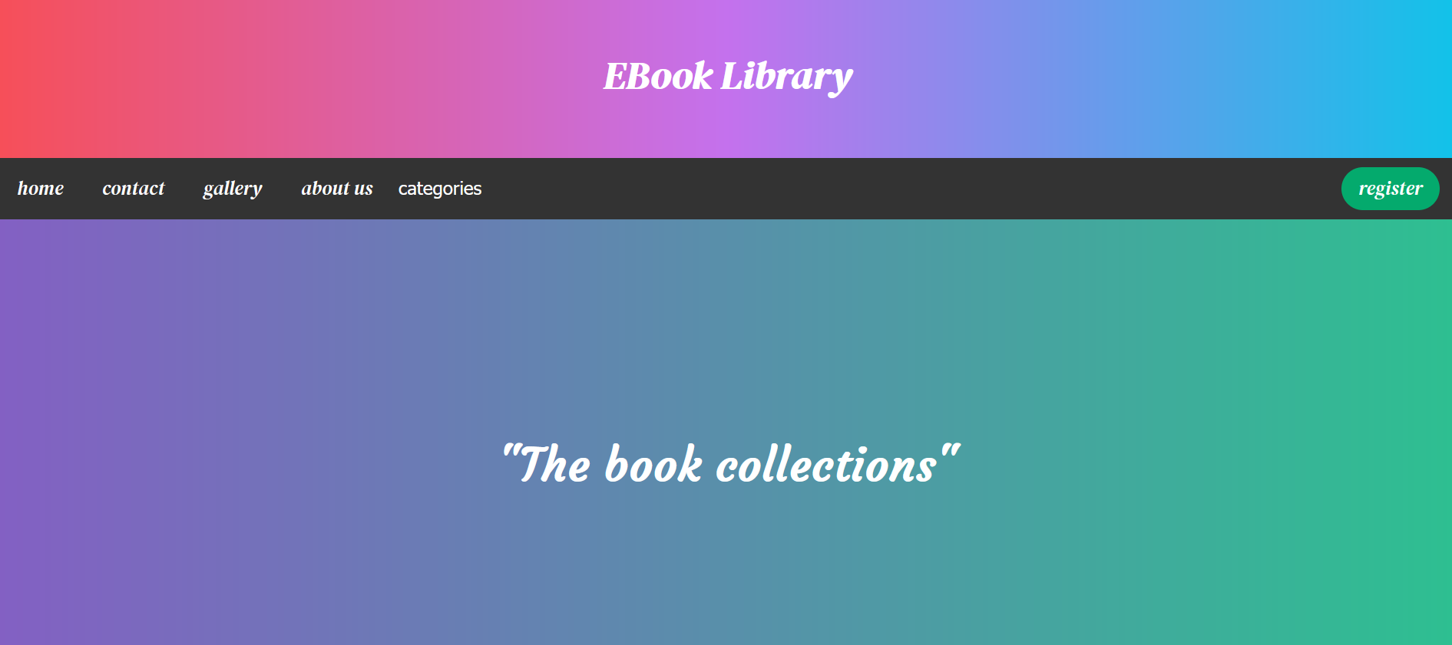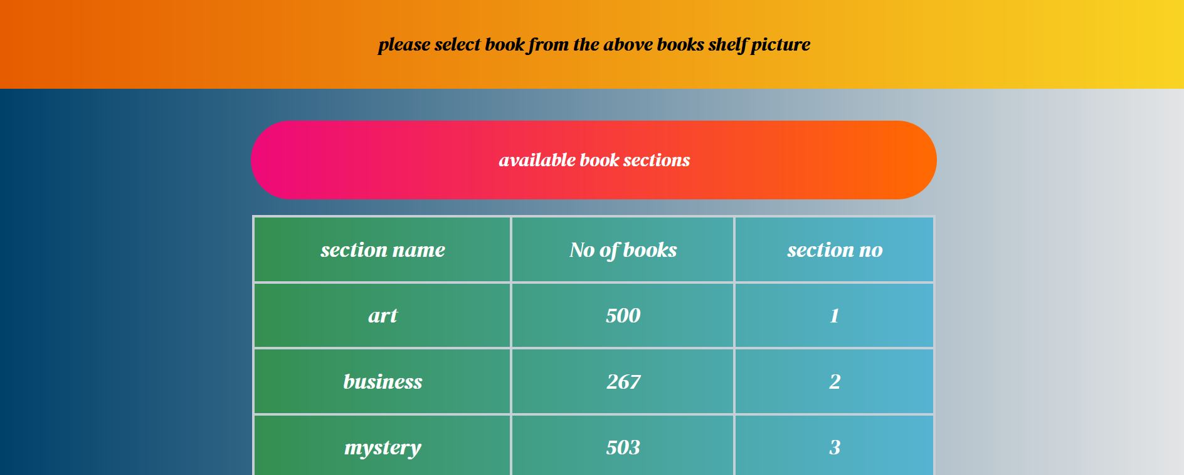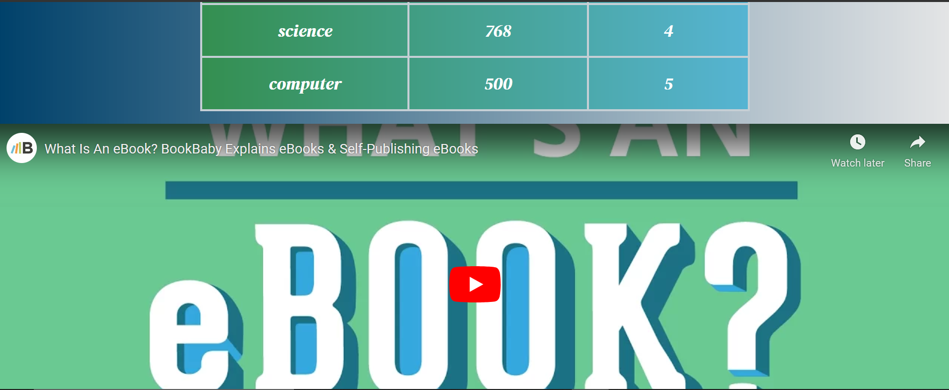

**2.Login.html**

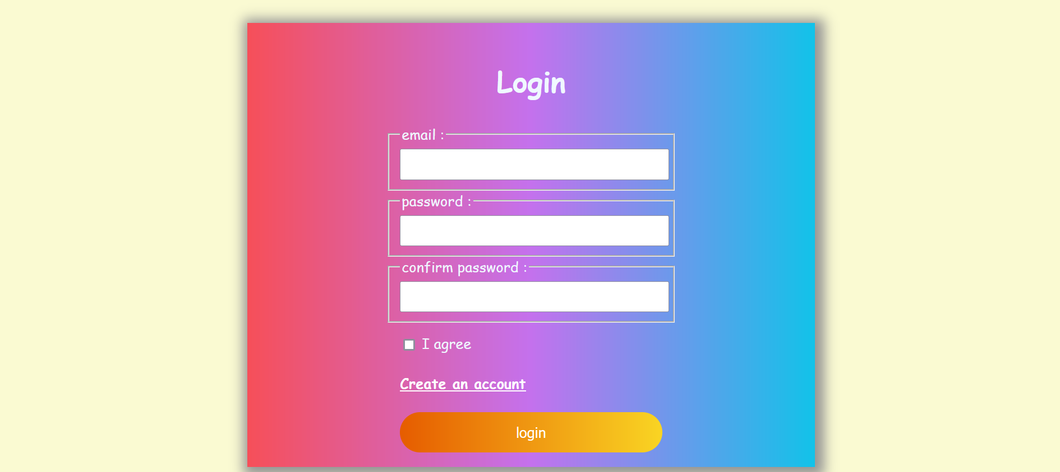

**3.signup.html**

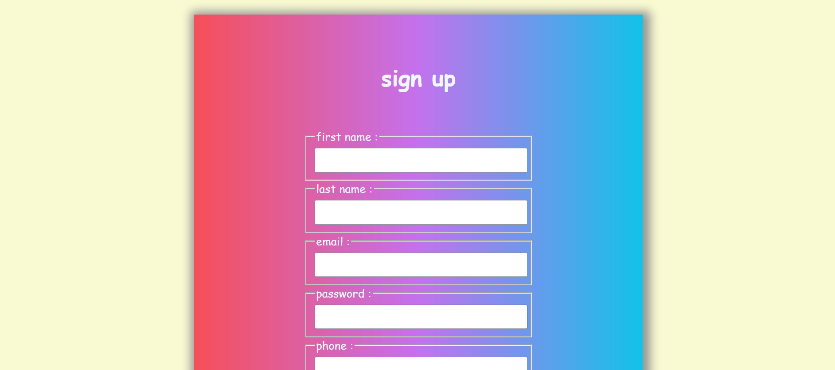

**4.gallery.html**



**5.aboutus.html**

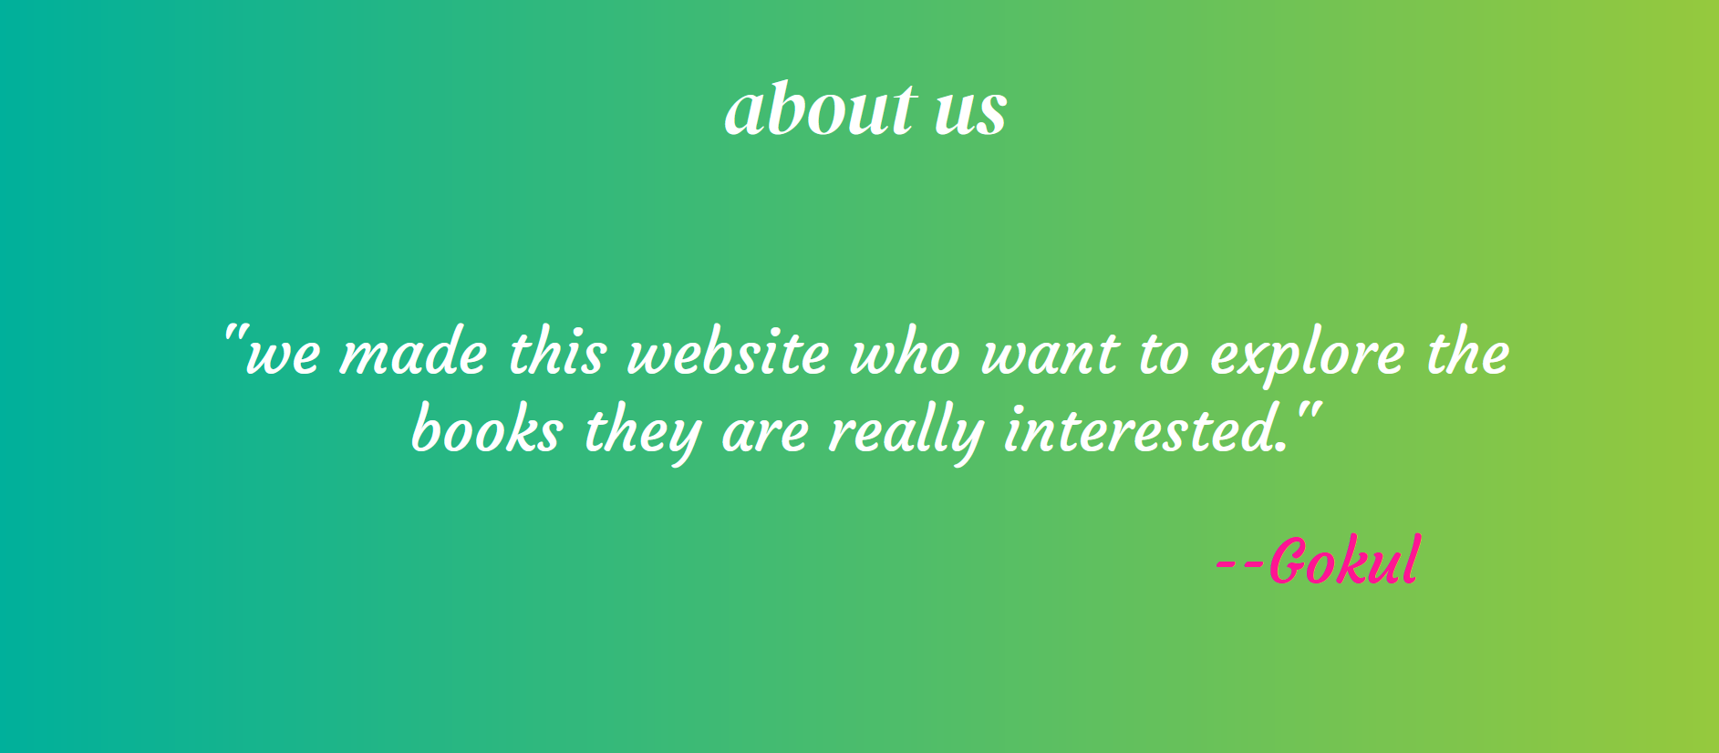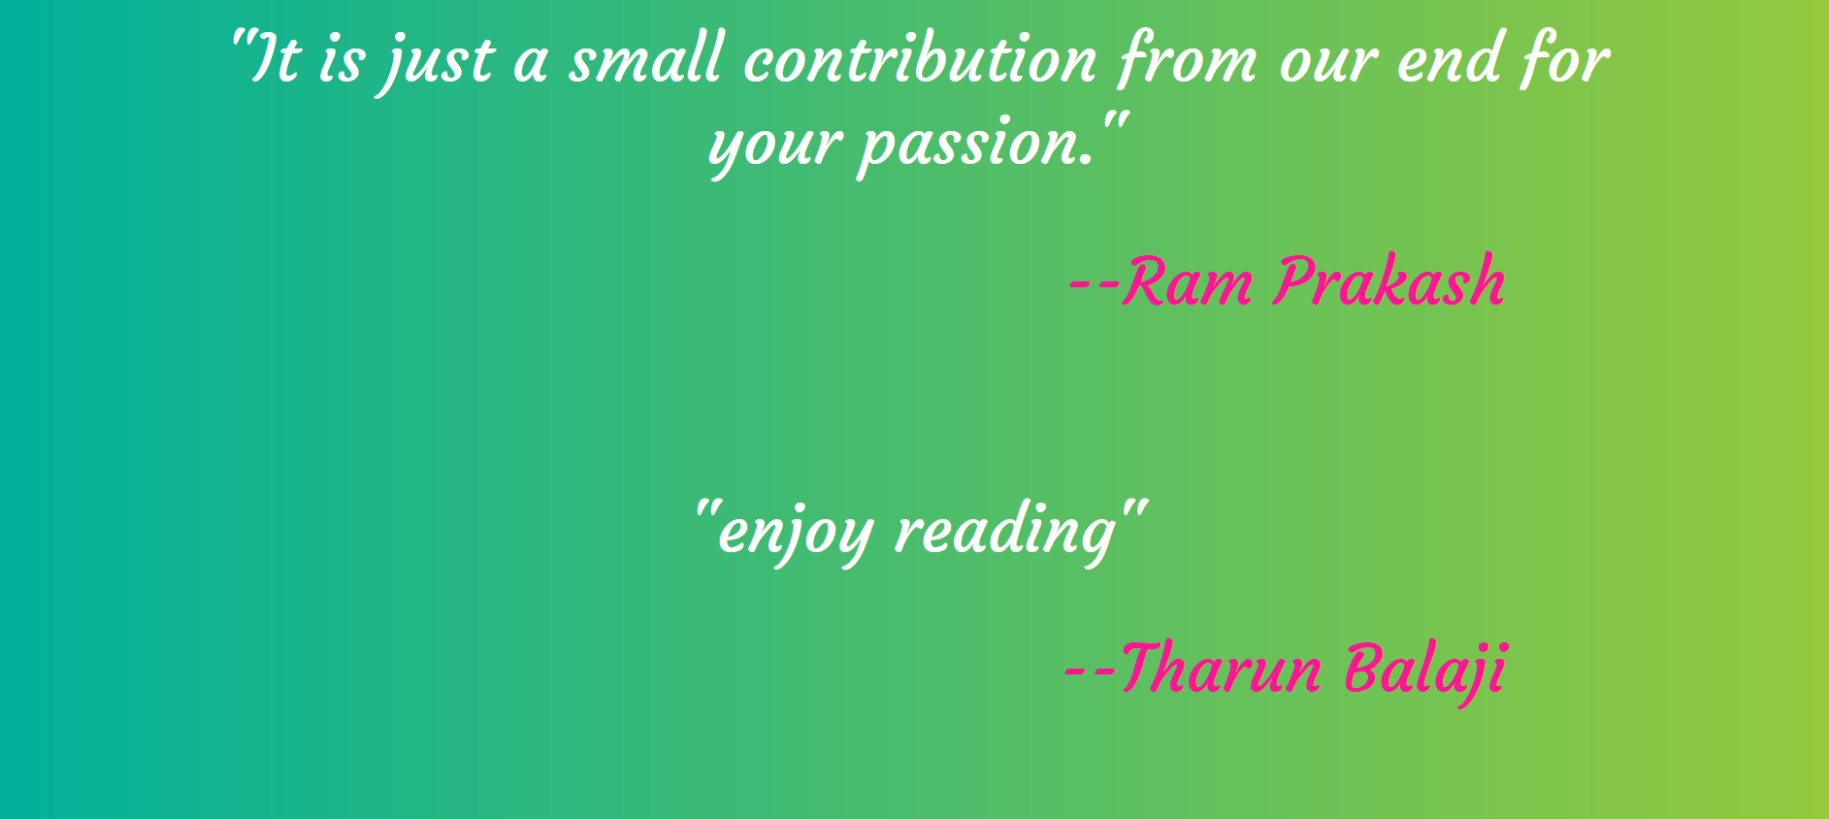

**Result:**

The above website is successfully completed and the output is verified.